UNIVERSITY OF LJUBLJANA
FACULTY OF SPORT
Gortanova ulica 22
1000 LJUBLJANA

Ref. no.: __________ /2010
Date: 31.3.2010

INVITATION TO TENDER

Subject of the public contract: FULL BODY INERTIAL MOTION CAPTURE SUIT

Orientation value: under 50.000 € (net price)

You are invited to use the enclosed forms to submit your tender for this public procurement.

CONTRACT SPECIFICATION:

Brief description of public contract:
The subject of the public procurement is Full body motion capture system for measuring 3D body movement in real time. The system must base on large enough number of 3D inertial motion sensors to define minimum of 23 main body segments and 22 joints. The system has to enable measurements of: 3D position, 3D velocity, 3D acceleration, 3D orientation, 3D angular velocity, 3D angular acceleration of segments and 3D joint angles at minimum of 100 samples per second. Furthermore, the system has to visualize 3D character movement and main kinematical parameters in real time. More detailed information about technical demands of the measurement system can be found in technical specification of the tender documents.

Minimal technical specifications on equipment that is the subject of the tender:
- Inertial 3d Kinematic measurement system based on accelerometers, gyroscopes, and flux meters (orientation)
  - Minimum accelerometer range ± 150 m/s2 (15 g)
  - Minimum gyroscope range 1000 deg/s
- Output data of a all main human body segments: min 23 segments and 22 joints
- Minimum sampling rate of the system is 100 Hz
- Real-time measurement capture of human movement and visualization of
  - 3D digital character animation with user operated view-angle
  - 3D kinematic graphs
- Attachment of sensors to the body with elasticised Velcro straps
  - Possibility to change the measurement system from one to another subject in short time
  - And minimal skin motion artefact
- Quick setup and easy calibration process (preparation time should not exceed 30 min)
  - Possibility of use of pre-measured anthropometric human data for calibration
- Wireless transmission of measured data to a PC compatible computer (Windows XP or higher)
- Access to directly measured inertial sensor data (accelerations, angular velocities etc.)
- Each segment’s measurement should include 3D position, 3D velocity, 3D acceleration,
3D orientation, 3D angular velocity, 3D angular acceleration and 3D joint angle
- Build in calculation of the Centre of Mass of a human
- Output to XML and BVH readable files as well as to C3D biomechanical files
- Export of animations to AVI video files
- Synchronization with video recordings
- Low sensors weight and low total on-body system’s weight
- Long operating measurement time
  - Possibility to quickly change batteries on field measurements
- Indoor and outdoor use
  - Possibility to use equipment in cold and warm temperatures (min range: -15 to +40 deg Celsius)
- The whole system should be packed in a portable protection suitcase for easy transportation
- Software development kit for custom build applications used with the system should be included
- Minimum 2-year warranty

Terms, which must be provided by the tenderer:
- The equipment must meet listed minimal technical specifications. Tender which will not meet the minimum technical specifications listed, will be eliminated from the further procurement procedure.

Instructions for the preparation of the tender:
The tender documents shall be submitted in the English or Slovenian language and the prices stated in euros.

To ensure validity of the tender, the tenderer shall submit the complete documentation in the following order:
- Statement
- Tender
- Cost estimate
- Contract

Enter the prices in the cost estimate form and multiply them with quantities and add up the resulting values. The price shall be inclusive of all costs, discounts, rebates and value added tax. The cost estimate shall be valid until July 31, 2010.

The tender value of the contract is under 50.000 € (excluding VAT).

Payment periods from the date of receipt of correct invoice:
1st 30% (10 days after the invoice date)
2nd 30% (30 days after the invoice date)
3rd 40% (45 days after the invoice date).

Location of goods acceptance and/or service performance: To the Contracting Authority’s address.

Equipment acquisition date: no later than 30 days after signing the contract.

The tenderer may obtain detailed information on the preparation of the tender documentation at the

Contracting Authority’s address, contact person: dr. Matej Supej; (matej.supej@fsp.uni-lj.si; telephone: 00386 1 520 77 62).
Contact person for the tender documentation: Eva Lomšek (eva.lomsek@fsp.uni-lj.si ; telephone: 00386 1 520 78 40).

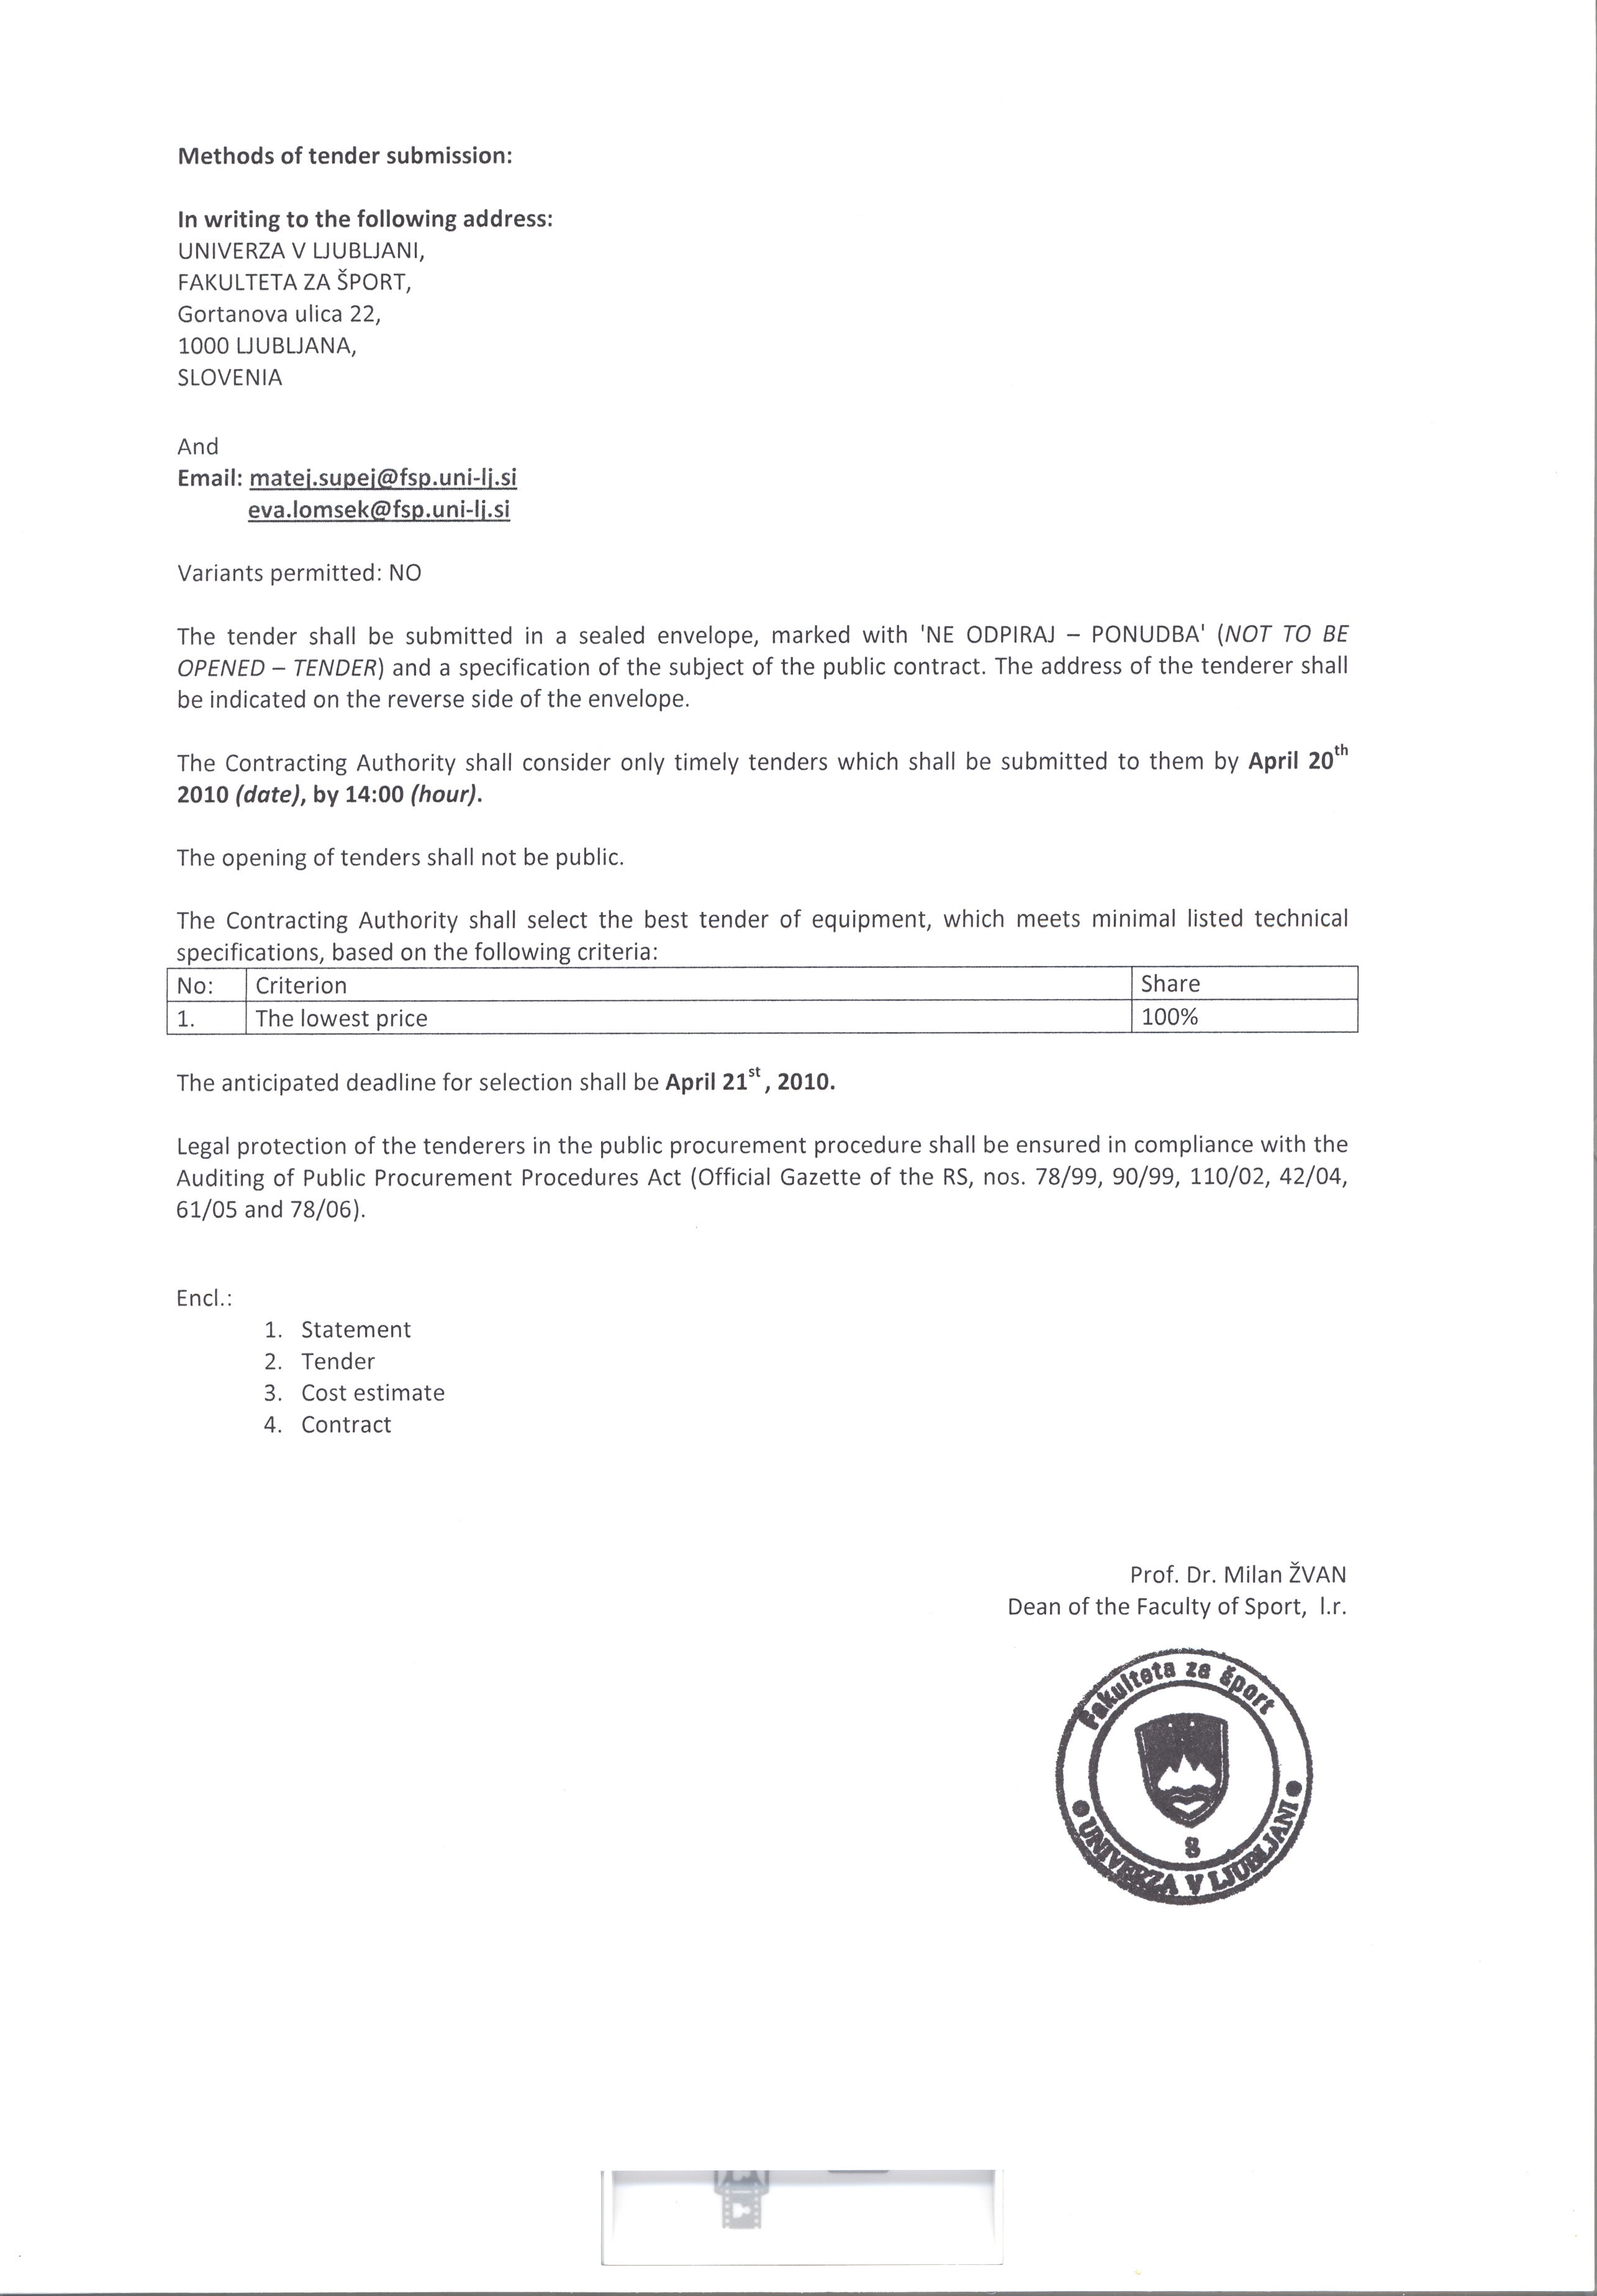
Methods of tender submission:

In writing to the following address:
UNIVERZA V LJUBLJANI,
FAKULTETA ZA ŠPORT,
Gortanova ulica 22,
1000 LJUBLJANA,
SLOVENIA

And
Email: matej.supej@fsp.uni-lj.si
eva.lomsek@fsp.uni-lj.si

Variants permitted: NO

The tender shall be submitted in a sealed envelope, marked with 'NE ODPIRAJ – PONUDBA' (NOT TO BE OPENED – TENDER) and a specification of the subject of the public contract. The address of the tenderer shall be indicated on the reverse side of the envelope.

The Contracting Authority shall consider only timely tenders which shall be submitted to them by April 20th 2010 (date), by 14:00 (hour).

The opening of tenders shall not be public.

The Contracting Authority shall select the best tender of equipment, which meets minimal listed technical specifications, based on the following criteria:
No: | Criterion | Share
1. | The lowest price | 100%

The anticipated deadline for selection shall be April 21st , 2010.

Legal protection of the tenderers in the public procurement procedure shall be ensured in compliance with the Auditing of Public Procurement Procedures Act (Official Gazette of the RS, nos. 78/99, 90/99, 110/02, 42/04, 61/05 and 78/06).

Encl.:
1. | Statement
2. | Tender
3. | Cost estimate
4. | Contract

Prof. Dr. Milan ŽVAN
Dean of the Faculty of Sport, l.r.

UNIVERSITY OF LJUBLJANA
FACULTY OF SPORT
Gortanova ulica 22
1000 LJUBLJANA
Ref. no.:
Date:

T E N D E R N O. ________________

- Description of the subject of the public contract:

FULL BODY INERTIAL MOTION CAPTURE SUIT

- This tender is valid until: _______________________________________________________________

- Tender price (in EUR; inclusive of VAT and discounts): _________________________ (fixed price; all costs included)

- Details on the tenderer:

Company name:

Legal representative:

VAT ID no.: Company registration no.:

Address:

E-mail: Transaction account:

Tel.: Fax:

Contact person:

Responsible person:

Should any data be inconsistent with those above, please, provide accurate information.

THE TENDERER AGREES WITH THE TERMS AND CONDITIONS OF THE PUBLIC PROCUREMENT.

Place and date: Tenderer’s signature and stamp:

______________________________________________ ______________________________________________
UNIVERSITY OF LJUBLJANA
FACULTY OF SPORT
Gortanova ulica 22
1000 LJUBLJANA

Ref. no.:
Date:

Tenderer:

S T A T E M E N T

Subject of the public contract:

We hereby declare under criminal and material liability:

No. | Terms and conditions | Compliant
1. | We accept the terms and conditions stipulated in the tender documentation and shall conclude a contract with the Contracting Authority accordingly. | [ ]
2. | We have been registered in a professional or trade register. | [ ]
3. | We satisfy compulsory minimum conditions related to financial and economic suitability as stipulated in Article 44 of the Public Procurement Act (ZJN-2A). | [ ]

If you fulfil the above stated terms and conditions mark the appropriate boxes with ‘X’.

We confirm that the above data are true and correct and we shall support these data by adequate documentary evidence should this be required by the Contracting Authority.

Pursuant to the second paragraph of Article 41 of the Public Procurement Act (ZJN-2A) (Official Gazette of the RS, no. 16/08) we hereby agree that the Contracting Authority obtains information for the purpose of this public contract from official records.

Place and date: Tenderer’s signature and stamp:

______________________________________________ _____________________________________________

UNIVERSITY OF LJUBLJANA
FACULTY OF SPORT
Gortanova ulica 22
1000 LJUBLJANA
SLOVENIA

Number:

Date:

Tenderer:

PROFORMA INVOICE NO.: ____________________

No. | Quantity | Unit | Description | Price per unit  excl. tax | Total price per unit  excl. tax
1 | 1 | Qty (system) | - Inertial 3d Kinematic measurement system based on accelerometers, gyroscopes, and flux meters (orientation)  - Minimum accelerometer range ± 150 m/s2 (15 g)  - Minimum gyroscope range 1000 deg/s  - Output data of a all main human body segments: min 23 segments and 22 joints  - Minimum sampling rate of the system is 100 Hz  - Real-time measurement capture of human movement and visualization of  - 3D digital character animation with user operated view-angle  - 3D kinematic graphs  - Attachment of sensors to the body with elasticised Velcro straps  - Possibility to change the measurement system from one to another subject in short time  - And minimal skin motion artefact  - Quick setup and easy calibration process (preparation time should not exceed 30 min)  - Possibility of use of pre-measured anthropometric human data for calibration  - Wireless transmission of measured data to a PC compatible computer (Windows XP or higher)  - Access to directly measured inertial sensor data (accelerations, angular velocities etc.)  - Each segment’s measurement should include 3D position, 3D velocity, 3D acceleration,  3D orientation, 3D angular velocity, 3D angular acceleration and 3D joint angle  - Build in calculation of the Centre of Mass of a human  - Output to XML and BVH readable files as well as to C3D biomechanical files  - Export of animations to AVI video files  - Synchronization with video recordings  - Low sensors weight and low total on-body system’s weight  - Long operating measurement time  - Possibility to quickly change batteries on field measurements  - Indoor and outdoor use  - Possibility to use equipment in cold and warm temperatures (min range: -15 to +40 deg Celsius)  - The whole system should be packed in a portable protection suitcase for easy transportation
2 | 1 | Qty | - Software development kit for custom build applications used with the system should be included
3 | 1 | Services | - Minimum 2-year warranty
4 | 1 | Services | - Transport costs from the supplier to the address of the recipient
 |  |  | Total:

Date, place: Stamp and signature of the provider:

_______________________________ _______________________________

